**CONTENTS**

TRAINING 4 2

A – 04.PIE 2

B – 03. FIBWORDS 2

C – 03.EKO 2

D – 03.BOOKS1 3

E – 03.AGGRCOW 3

G – Lost Numbers 3

H – Vanya and Lanterns 3

I – 04.TRIPLE 4

J – 04.CLOPAIR 4

KẾT QUẢ TRAINING 3 4

# 

# **TRAINING 4**

## **A – 04.PIE**

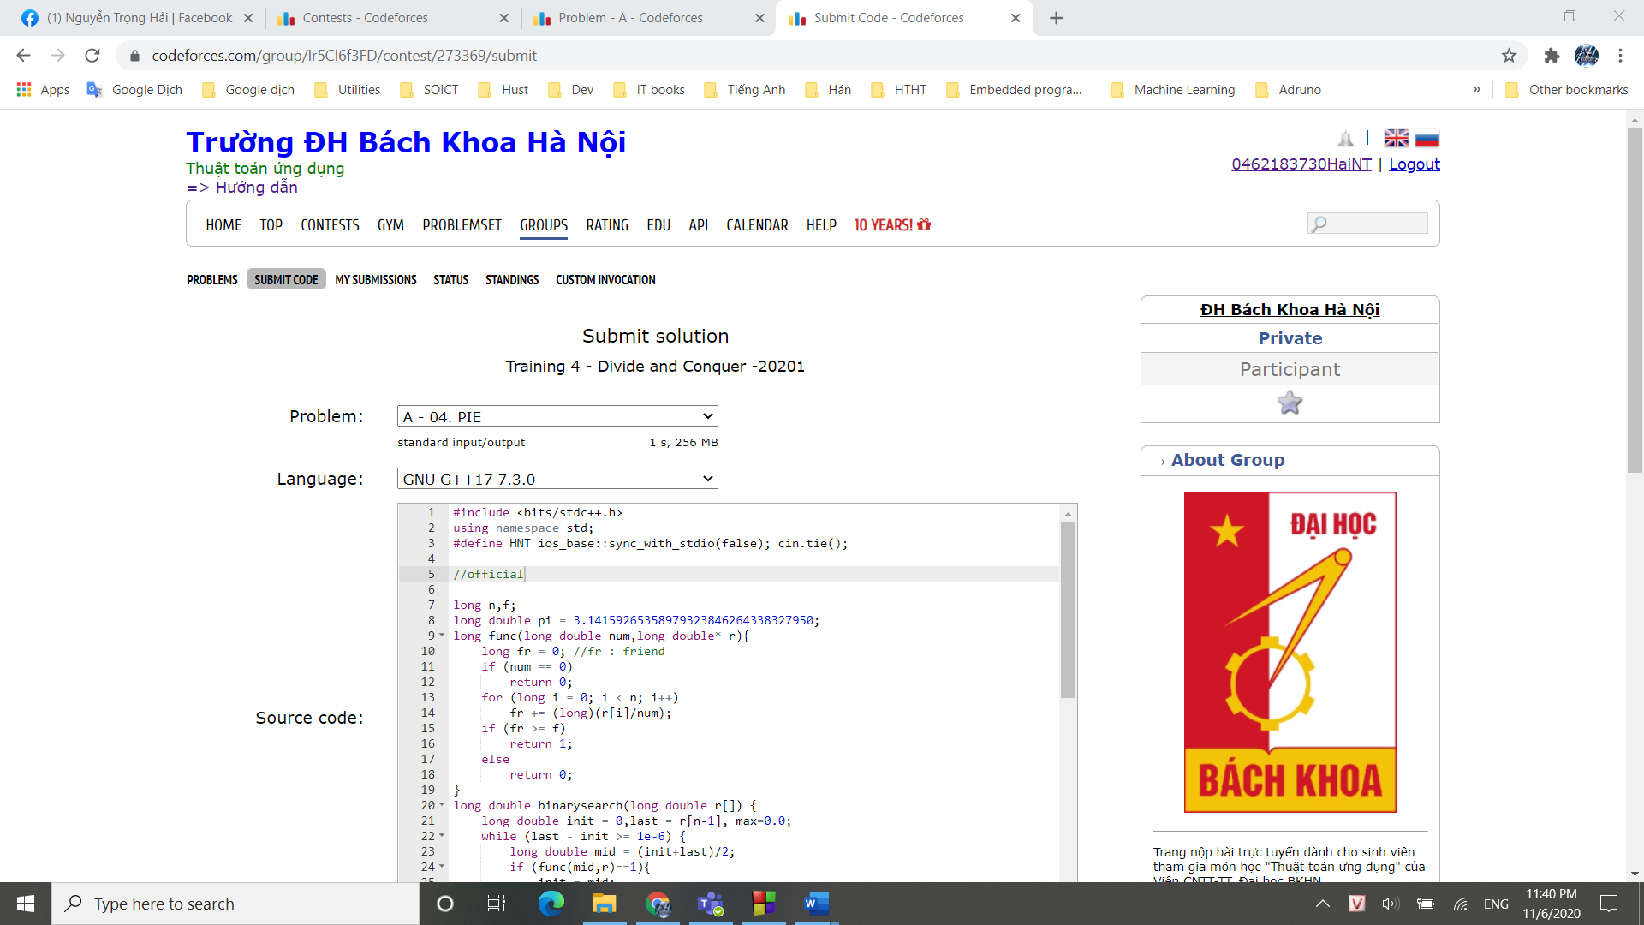

## **B – 03. FIBWORDS**

## **C – 03.EKO**

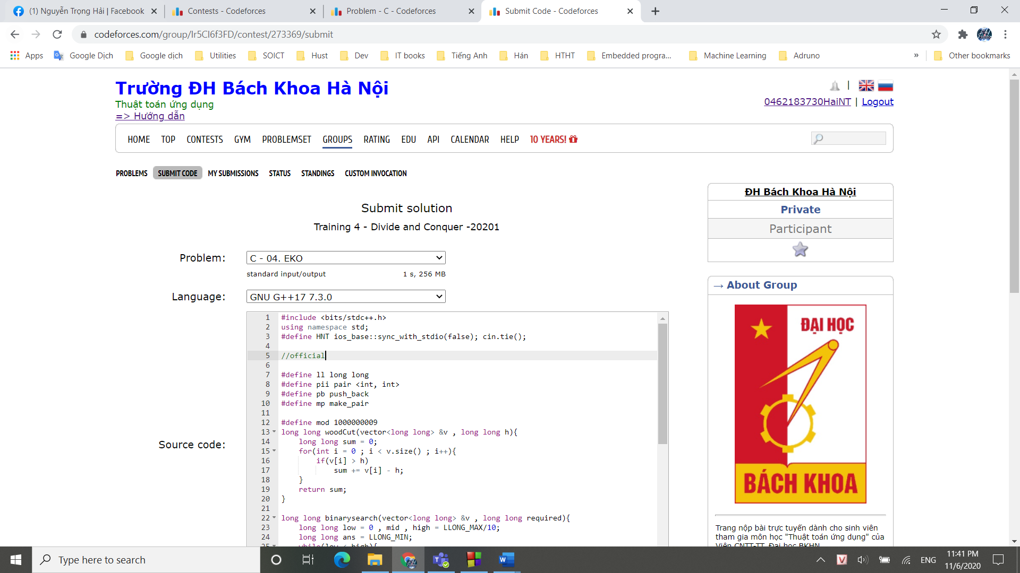

## **D – 03.BOOKS1**

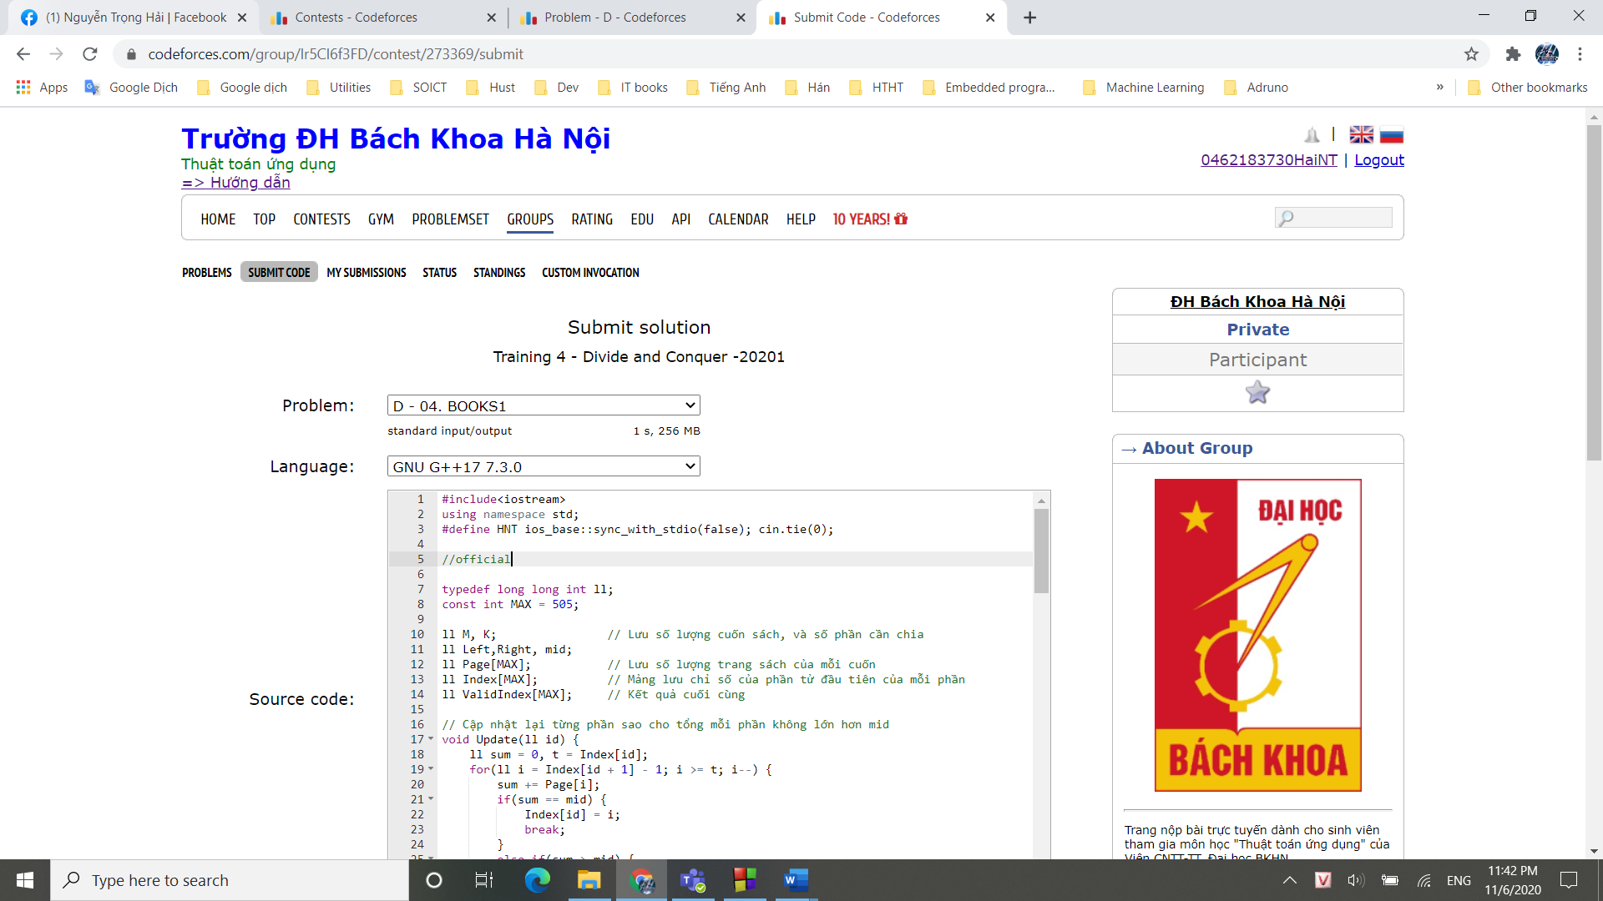

## **E – 03.AGGRCOW**

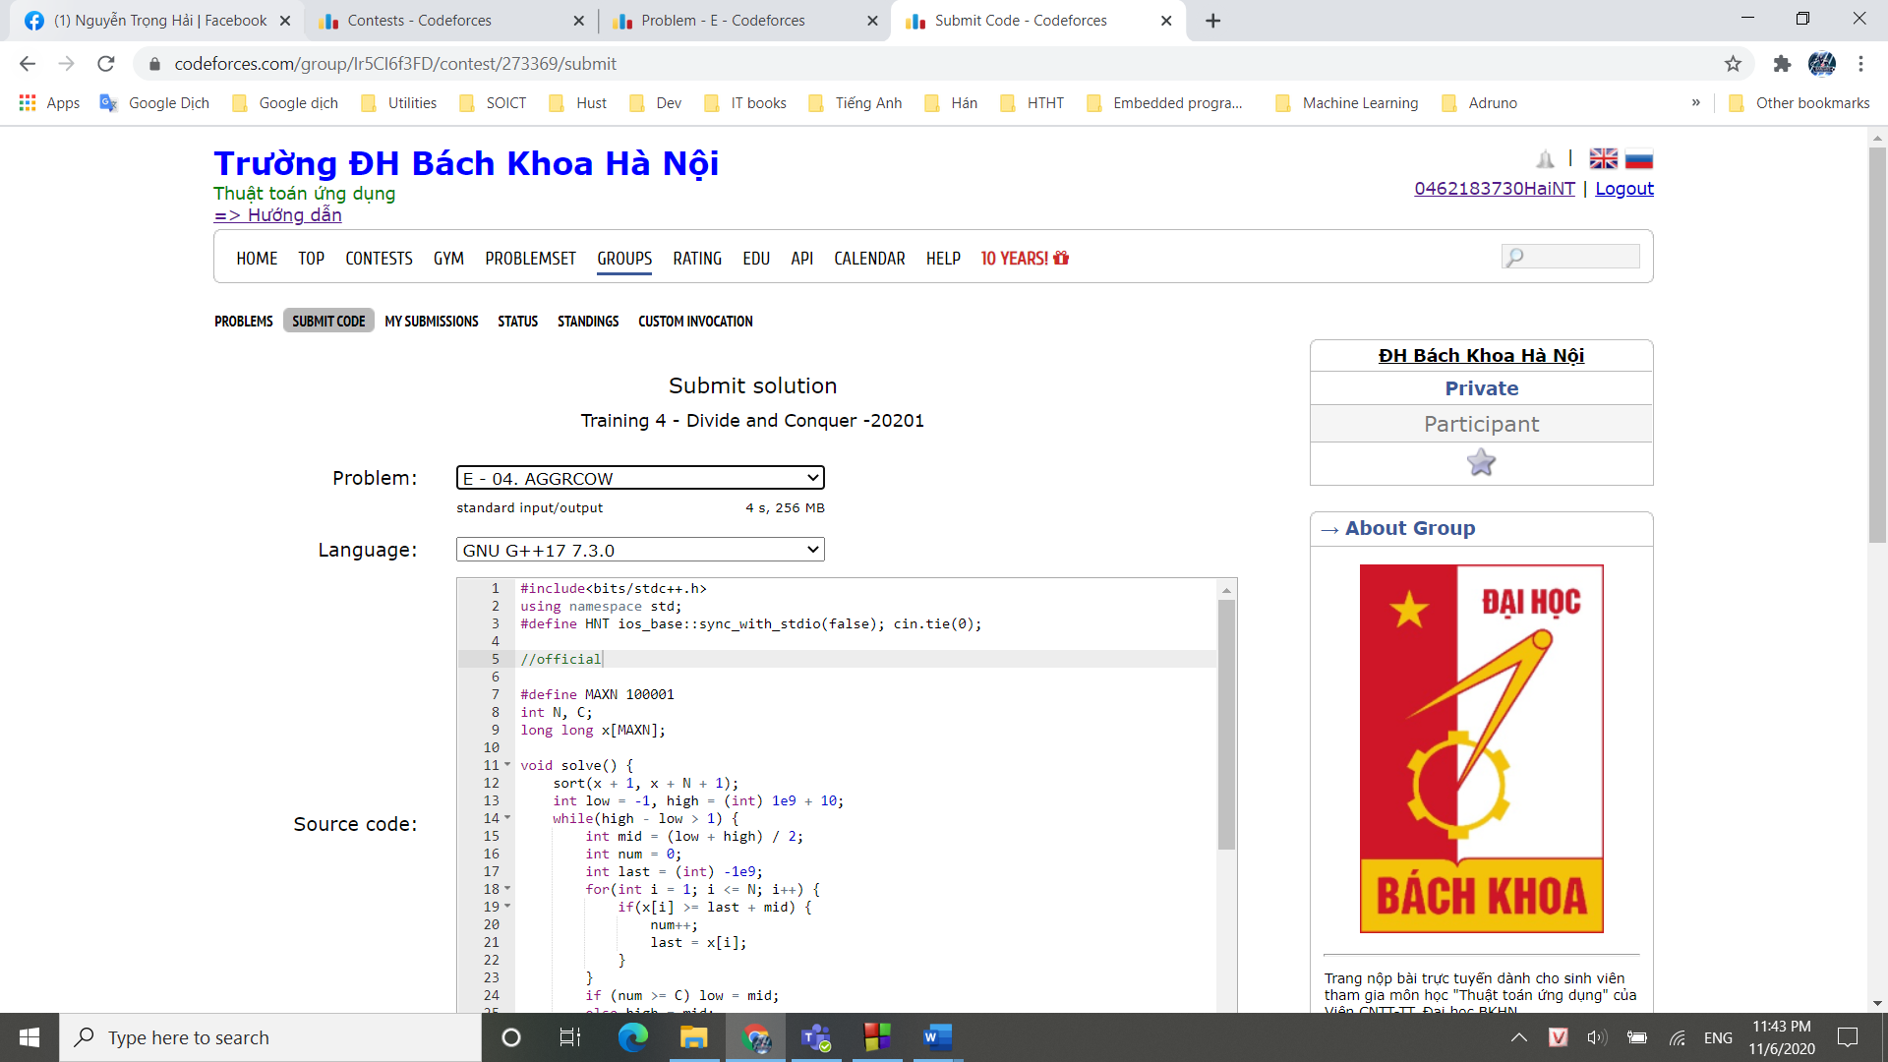

## **G – Lost Numbers**

## **H – Vanya and Lanterns**

## **I – 04.TRIPLE**

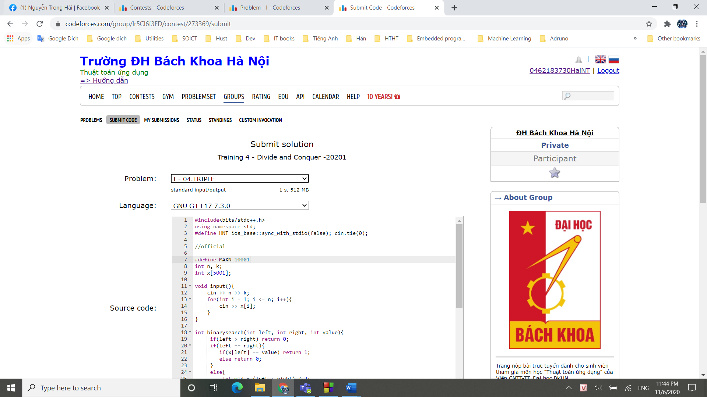

## **J – 04.CLOPAIR**

## **KẾT QUẢ TRAINING 3**

